A PROJECT REPORT

on

“NAME OF PROJECT”

Submitted to

KIIT Deemed to be University

In Partial Fulfilment of the Requirement for the Award of

BACHELOR’S DEGREE IN

COMPUTER SCIENCE & ENGINEERING
OR
INFORMATION TECHNOLOGY

BY

GROUP MEMBER A
GROUP MEMBER B
GROUP MEMBER C
GROUP MEMBER D

ROLL NUMBER A ROLL NUMBER B ROLL NUMBER C ROLL NUMBER D

UNDER THE GUIDANCE OF

GUIDE NAME


SCHOOL OF COMPUTER SCIENCE AND ENGINEERING

KALINGA INSTITUTE OF INDUSTRIAL TECHNOLOGY

BHUBANESWAR, ODISHA - 751024

MonthYear

A PROJECT REPORT

on

“NAME OF PROJECT”

Submitted to

KIIT Deemed to be University

In Partial Fulfilment of the Requirement for the Award of

BACHELOR’S DEGREE IN COMPUTER SCIENCE & ENGINEERING / INFORMATION TECHNOLOGY

BY

GROUP MEMBER A
GROUP MEMBER B
GROUP MEMBER C
GROUP MEMBER D

ROLL NUMBER A ROLL NUMBER B ROLL NUMBER C ROLL NUMBER D

UNDER THE GUIDANCE OF

GUIDE NAME

SCHOOL OF COMPUTER SCIENCE AND ENGINEERING

KALINGA INSTITUTE OF INDUSTRIAL TECHNOLOGY
BHUBANESWAE, ODISHA -751024
Month Year
KIIT Deemed to be University

School of Computer Science and Engineering
Bhubaneswar, ODISHA 751024

CERTIFICATE

This is certify that the project entitled

“NAME OF PROJECT“

submitted by

GROUP MEMBER A
GROUP MEMBER B
GROUP MEMBER C
GROUP MEMBER D

ROLL NUMBER A ROLL NUMBER B ROLL NUMBER C ROLL NUMBER D

is a record of bonafide work carried out by them, in the partial fulfilment of the requirement for the award of Degree of Bachelor of Engineering (Computer Science & Engineering / Information Technology) at KIIT Deemed to be university, Bhubaneswar. This work is done during year YYYY-YYYY, under our guidance.

Date: / /

(Guide Name)
Project Guide

Acknowledgements

We are profoundly grateful to GUIDE NAME of School of Computer Science and Engineering, KIIT Deemed to be University for his expert guidance and continuous encouragement throughout to see that this project rights its target since its commencement to its completion. .....................

Signature of GROUP MEMBER A

Signature of GROUP MEMBER B

Signature of GROUP MEMBER C

Signature of GROUP MEMBER D

ABSTRACT

Your abstract, paragraph 1.

Your abstract, paragraph 2.

Keywords: Write at least five keywords closely related to your project work.

Contents

1 | Introduction |  |  | 1
2 | Basic Concepts/ Literature Review |  |  | 2
 | 2.1 | Sub Section Name........................... |  | 2
3 | Problem Statement / Requirement Specifications |  |  | 3
 | 3.1 | Project Planning........................... |  | 3
 | 3.2 | Project Analysis (SRS)................. |  | 3
 | 3.3 | System Design ………………….. |  | 3
 |  | 3.3.1 | Design Constraints …… | 3
 |  | 3.3.2 | System Architecture (UML) / Block Diagram … | 3
4 | Implementation |  |  | 4
 | 4.1 | Methodology / Proposal ........................... |  | 4
 | 4.2 | Testing / Verification Plan ……………. |  | 4
 | 4.3 | Result Analysis / Screenshots …………. |  | 4
 | 4.4 | Quality Assurance …………………….. |  | 4
5 | Standard Adopted |  |  | 5
 | 5.1 | Design Standards . . . . . . . . . . . . . . . |  | 5
 | 5.2 | Coding Standards . . . . . . . . . . . . . . |  | 5
 | 5.3 | Testing Standards . . . . . . . . . . . . . . . |  | 5
6 | Conclusion and Future Scope |  |  | 6
 | 6.1 | Conclusion ……………………….. |  | 6
 | 6.2 | Future Scope ………………………. |  | 6
References |  |  |  | 7
Individual Contribution |  |  |  | 8
Plagiarism Report |  |  |  | 9

List of Figures

1.1 | IMAGE CAPTION ......................... | 2
4.1 | IMAGE CAPTION ......................... | 9

List of Tables

1.5 | TABLE CAPTION ......................... | 5
3.2 | TABLE CAPTION ......................... | 7

NAME OF PROJECT

Chapter 1

Introduction

The content of the report must be in “Times New Roman” and font size is 12.

This section must discuss the current need of the project and details about the gaps present in the current available solutions.

Paragraph-wise, you can describe the importance of this project along with the structure of the report.

There is no need of subsections in Introduction section.

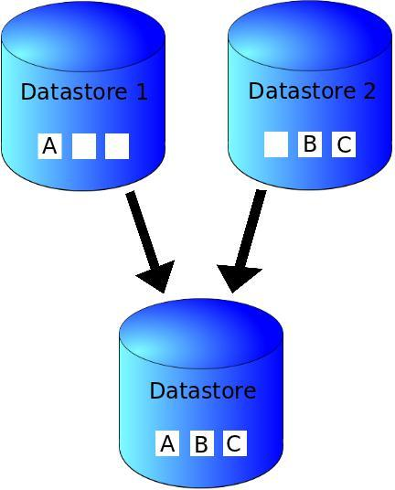

Figure 1.1: IMAGE CAPTION

School of Computer Science and Engineering, KIIT, BBSR 1

NAME OF PROJECT

Chapter 2

Basic Concepts/ Literature Review

This section contains the basic concepts about the related tools and techniques used in this project. For research work, present the literature review in this section.

2.1 Subsection………….

In the sub-sections, write a description of the concepts of different tools and techniques. So that, if a reader wants to understand this project must read these basic concepts, which will help the readers to understand the project well.

Add as many sub-sections as required.

School of Computer Science and Engineering, KIIT, BBSR 2

NAME OF PROJECT

Chapter 3

Problem Statement / Requirement Specifications

In this section, write the Problem Statement (the problem for which you are working on to give some solution). When a student works on any development project, they must gain sufficient knowledge related to the project and based on this they can define a problem statement. In software development projects, the student must present the SRS according to the IEEE format, in this section.

3.1 Project Planning

Write about the steps to be followed while planning to execute the project development. It can be represented using list of requirements of the user or features to be developed.

3.2 Project Analysis

After the requirements are collected or the problem statements is conceptualized, this needs to be analyzed for finding any short of ambiguity, mistake, etc.

3.3 System Design

3.3.1 Design Constraints

Here you can mention the working environment such as the software, hardware used. Any experimental setup or environmental setup must be described here.
3.3.2 System Architecture OR Block Diagram
In this sub-section, explain the System Architecture / Hardware Designs / Block Diagrams used to understand your project work.

School of Computer Science and Engineering, KIIT, BBSR 3

NAME OF PROJECT

Chapter 4

Implementation

In this section, present the implementation done by you during the project development.

4.1 Methodology OR Proposal
This sub-section contain the methods you have used to complete the project, or some algorithms used and developed for your project work. Details about the steps adopted for competing the project work.

4.2 Testing OR Verification Plan
After project work is complete, it must have some verification criterion so that we can decide whether the project was satisfactorily completed or not. This is called Testing or verification. For example, in software development, some test case must be included and used to verify the outcome of the project.

Table 1: Result analysis of the experiment
Test | Test Case Title | Test Condition | System Behavior | Expected Result
ID
T01 | AAAA | BBBB | CCCC | DDDD
T02 | AAAA | BBBB | CCCC | DDDD
T03 | AAAA | BBBB | CCCC | DDDD

4.3 Result Analysis OR Screenshots
In this subsection, the output of the experiment or study in terms of some graphs or plots must be presented. Also, if some implementation is done then it’s screenshots can be presented here, so as to showcase the proof of the output.

4.4 Quality Assurance
In a working organization, if a department is there to verify the quality of your work, they can produce a certificate or guidelines followed.

School of Computer Science and Engineering, KIIT, BBSR 4

NAME OF PROJECT

Chapter 5

Standards Adopted

5.1 Design Standards
In all the engineering streams, there are predefined design standards are present such as IEEE, ISO etc. List all the recommended practices for project design. In software the UML diagrams or database design standards also can be followed.

5.2 Coding Standards
Coding standards are collections of coding rules, guidelines, and best practices. Few of the coding standards are:
Write as few lines as possible.
Use appropriate naming conventions.
Segment blocks of code in the same section into paragraphs.
Use indentation to marks the beginning and end of control structures. Clearly specify the code between them.
Don’t use lengthy functions. Ideally, a single function should carry out a single task.
…...

5.3 Testing Standards
There are some ISO and IEEE standards for quality assurance and testing of the product. Mention the standards followed for testing and verification of your project work.

5.4 Cost Analysis

The project carries some equipment or software, then the student has to perform the cost analysis to compare their solution with existing solutions.

School of Computer Science and Engineering, KIIT, BBSR 5

NAME OF PROJECT

Chapter 6

Conclusion and Future Scope

6.1 Conclusion

6.2 Future Scope

School of Computer Science and Engineering, KIIT, BBSR 6
NAME OF PROJECT

References (Examples)

- J. Redmon, S. Divvala, R. Girshick, and A. Farhadi, "You Only Look Once: Unified, Real-Time Object Detection," in Proc. IEEE CVPR, 2016, pp. 779-788.
- R. Olmos, S. Tabik, and F. Herrera, "Automatic Handgun Detection Alarm in Videos Using Deep Learning," Neurocomputing, vol. 275, pp. 66-72, 2018.
- M. Grega, A. Matiolanski, P. Guzik, and M. Leszczuk, "Automated Detection of Firearms and Knives in a CCTV Image," Sensors, vol. 16, no. 1, p. 47, 2016.
- J. Lim et al., "Deep Multi-Level Feature Pyramids: Application for Non-Canonical Firearm Detection in Video Surveillance," Engineering Applications of AI, vol. 97, 2021.
- A. Warsi et al., "Gun Detection System Using YOLOv3," in Proc. IEEE International Conference on Smart Instrumentation, 2021.

School of Computer Science and Engineering, KIIT, BBSR 7

NAME OF PROJECT

SAMPLE INDIVIDUAL CONTRIBUTION REPORT:

<TITLE OF THE PROJECT IN FONT SIZE 14, FONT STYLE TIMES NEW ROMAN, BOLD AND CENTERED>

<Student Name (in capital letters in font size 12, Times New Roman and centered>
<Student Roll number (font size 12, Times New Roman and centered>

Abstract: A short description of the aim and objective of the project work carried out in 3-4 lines. This part should be common to all students in the group. The font size and style will remain same from this point onwards. The font size will be 12 and font style will be Times New Roman. The line spacing will be 1.5.
This report should be prepared in A4 page format with ‘default’ option under ‘Margin’ of the ‘Page Layout’ tab in Microsoft Word. Word limit for this section is 80.

Individual contribution and findings: The student should clearly indicate his/her role in the project group and the contribution in implementing the project work. The student should also outline his /her planning involved in implementing his/her part in the work. This contribution report should be different for every student in the group. The student would also write his./her technical findings and experience while implementing the corresponding part of the project. The overall contribution report should not be less than 1 page for each student. The Student should provide both the soft copy and signed hard copy to the project supervisor.

Individual contribution to project report preparation: Student should mention his/her role in preparing the group project report indicating which chapter and portions contributed.

Individual contribution for project presentation and demonstration: Student should mention his/her role in preparing presentations and part of the project demonstrated.

Full Signature of Supervisor: Full signature of the student:
……………………………. ……………………………..

School of Computer Science and Engineering, KIIT, BBSR 8

TURNITIN PLAGIARISM REPORT
(This report is mandatory for all the projects and plagiarism
must be below 25%)

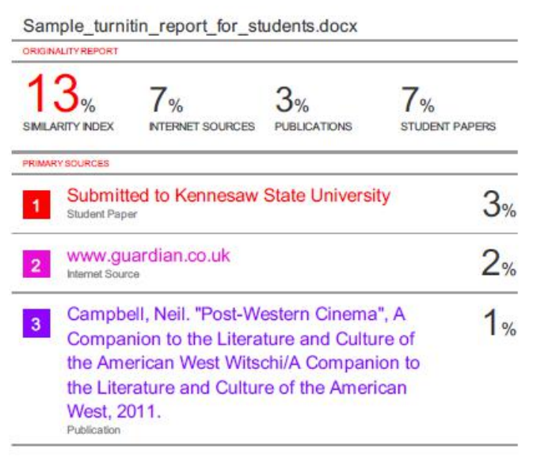

School of Computer Science and Engineering, KIIT, BBSR 9



